Do you run Ranorex Studio and your AUT with admin rights ?  
  
Would you be able to upgrade to the latest Ranorex version to see if this problem still appears?

Hello Yosuva,  
  
Here is some other workarounds which need to be checked:

1.   Server needs to have "sapgui/user_scripting" global parameter enabled (value "TRUE"). Only then has the client side scripting enable/disable setting any effect. If there are any security limitations in your company and it's not allowed for everyone to have scripting access, there is a posibility to enable it for only specific people through combining the "sapgui/user_scripting" parameter with "sapgui/user_scripting_per_user".

All the required information is in the previously linked SAP Scripting Security documentation.

1. Please try the 64 bit version with full permissions and try spy to see if the elements are accessible.

2.   Try toggling the bit bridge (Settings > Advance > Enable 32/64 Bit Bridge) and see if this helps.

3.   Try  removing SAP GUI from whitelists and check if there is any difference

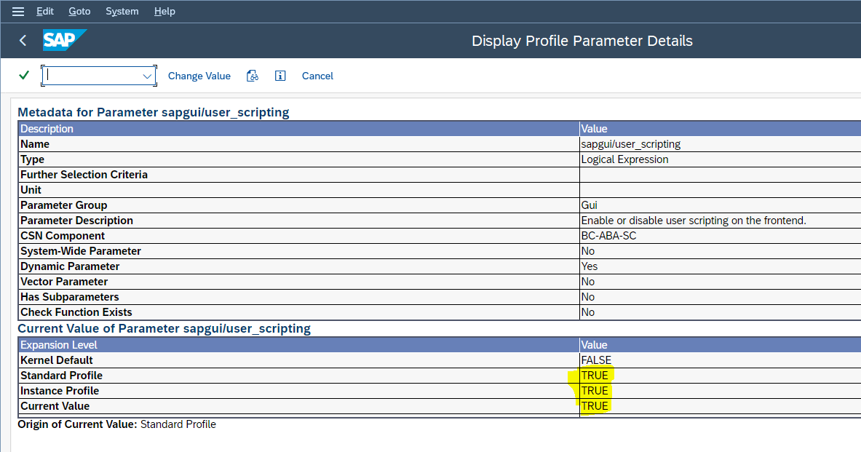,   
  
1) Have you tried with "System Dependent" Theme in SAP GUI Options dialog?  
  
If not tried so far please follow the step below to change,  
Open Options > Visual Design > Change Theme  
  
2) Try following settings to see if it makes any difference :  
  
Switch to the native WPF plugin in Ranorex Studio under Settings > Plugins > WPF > WPF Legacy/UIA interaction > WpfImprovedOnly  
  
3) Can you try same test on a different machine and check if there is a different behavior ?

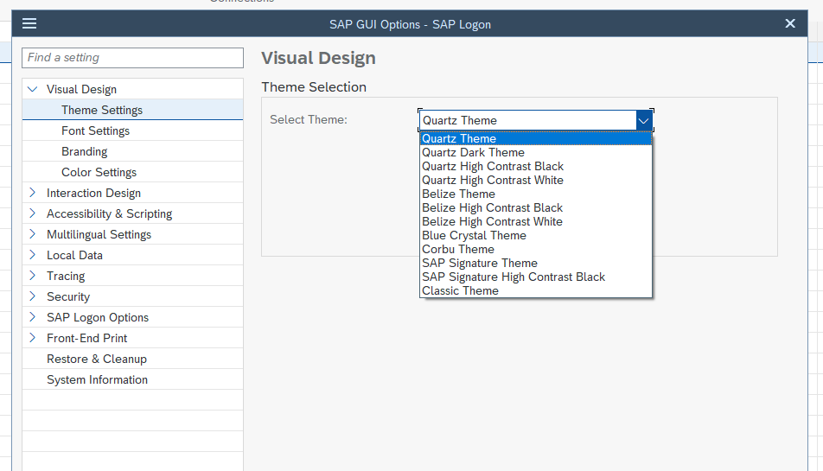

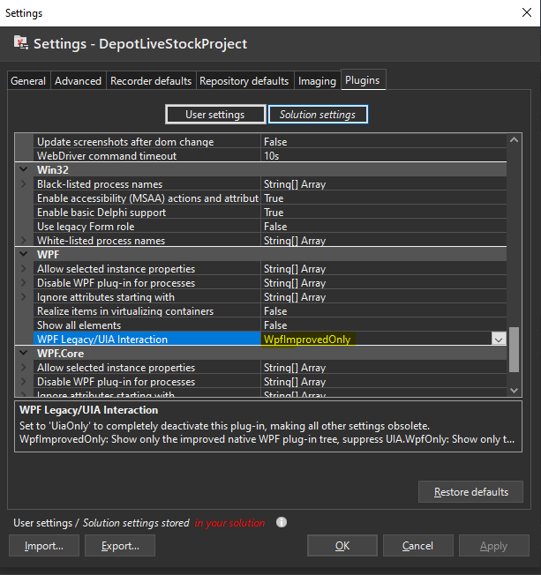

1. Try adding an Invoke action with PerformClick() in the recording, as a functionally for clicking on the object.  
     
   2) Insert some delay before click and check if this helps  
      
   3) Try toggle "Use asynchronous dispatching of mouse and keyboard events" option (Ranorex settings >> Advanced tab) from its current state to the opposite state.  
     
   4)  Can you try to change the screen resolution on your PC and see if it helps?  
     
   5) Can you try changing the settings for WPF into UIA only and check if it makes any difference?  
     
   You can check the "Visible" attribute using Ranorex Spy to see if the window is in background or not.

Another thing you might try is using EnsureVisible method, which tries to bring the element to visible area of screen.  
  
repo.elementname.EnsureVisible();